**CADENAS continues pioneering role: First 3D CAD model app for Windows 10 is now available**

CADENAS continues pioneering role: First 3D CAD model app for Windows 10 is now available

**Augsburg, Germany, 19th April 2016.** Since 2012, there has been the “3D CAD models engineering“ app from CADENAS, which serves engineers and purchasers as download service and calculation tool for 3D data. Due to the growing popularity and the increasing download figures in the Google Play and iTunes Store, the software developer now decided to offer the app also for Windows 10 as mobile and desktop version.

“At the beginning of the year we looked at the vast amount of positive customer feedback that was published in the Google Play Store. Of course we do not wish to withhold this service from Windows 10 users and therefore gave them access to the 3D CAD model app“, says Jürgen Heimbach, CEO at CADENAS.

Moreover, he sets an ambitious target for this year: “Currently we have 611,000 downloads of our app from the Google Play and iTunes Store. This year we are striving to break the one million barrier. We would like to further strengthen our proven dominant position in the field of 3D CAD model app downloads. Everyone can convince himself about the supremacy compared to other 3D CAD model app providers in the online stores. The installation figures especially prove this.“

**Far more than CAD models**

The app helps engineers and purchasers from the mechanical and plant engineering as well as the automotive sector to find the right 3D CAD model in the desired format in a targeted way. The PARTcommunity app is based on CADENAS’ eCATALOGsolutions technology. Furthermore the CAD models are manufacturer-certified and available in 85 formats for the most current CAD systems like Solid Edge®, NX™, Parametric, Autodesk® Inventor®, AutoCAD®, CATIA®, SolidWorks®, Creo™ etc.

These are the extensive features of the PARTcommunity app: Product configuring extended product information such as pictures and Augmented Reality, case studies of the respective components in practice, requests for non-binding offers, direct contact to the manufacturers, extensive support and company news.

Get it on Windows 10:

<https://www.microsoft.com/de-de/store/apps/3d-cad-models-engineering/9nblggh5rmzm>

**Press Images:**

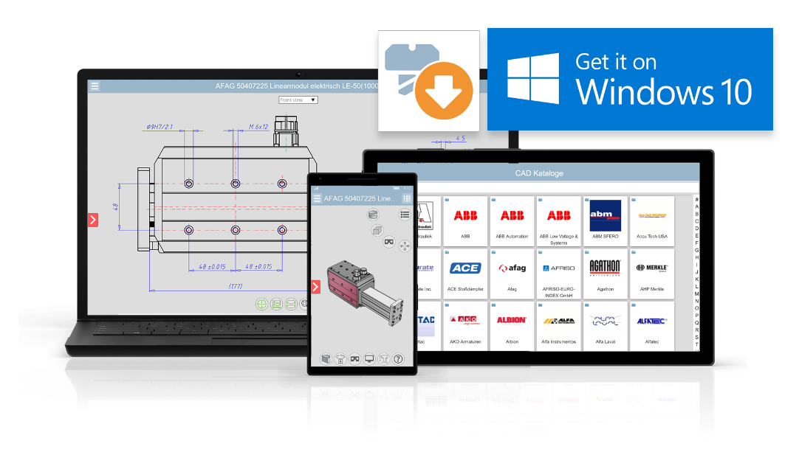

**Caption 1:** Due to the growing popularity and the increasing download figures the software developer now decided to offer the app also for Windows 10 as mobile and desktop version.

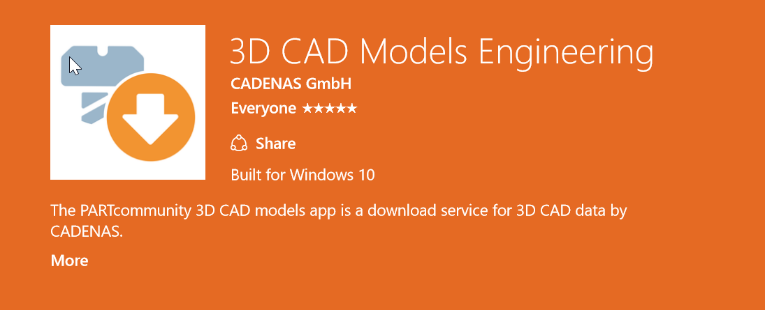

**Caption 2:** Furthermore the CAD models are manufacturer-certified and available in 85 formats for the most current CAD systems like Solid Edge®, NX™, Parametric, Autodesk® Inventor®, AutoCAD®, CATIA®, SolidWorks®, Creo™ etc.

This press release and accompanying images are available for download from our website: [www.cadenas.de/press/press-releases](http://www.cadenas.de/press/press-releases)

**About CADENAS**

CADENAS is a leading software developer in the areas of Strategic Parts Management and parts reduction (PARTsolutions), as well as Electronic Product Catalogs (eCATALOGsolutions). With its customized software solutions, the company acts as a link between the component manufacturers with their products and the purchasers.

With its 300 employees at 17 international subsidiaries, the name CADENAS (Hispanic: process chains) has been standing for success, creativity, support and process optimization since 1992.

For further information, please visit: www.cadenas.de/en